Experiment no 4

AIM: - To write VHDL code for Keypad Interface

Objective: - To write the VHDL code for Key board interface and verify the result for onboard
Key board on 7-segment Display.
SOFTWARE: Xilinx 13.4
THEORY: -
FPGA-A has a two multiplexed seven segment displays .Each individual character has a separate cathode control input.
To light an individual signal, drive the individual segment control signal High along with the associated cathode control signal for the individual character. The control signal is high, enabling the control inputs for the left-most character. The segment control inputs, A through G and DP, drive the individual segments that comprise the character. A High value lights the individual segment, a Low turns off the segment.
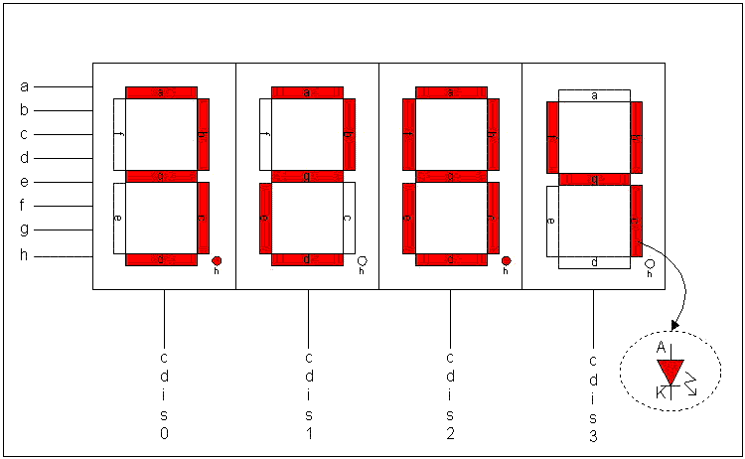
Figure 1: Seven Segment Display

The two types of the seven segment displays are as shown below
- Common Cathode Display: In this type of display the cathode of all the LEDs are tied together and the anode terminals decides the status of the LED, either ON or OFF.
- To turn ON the LED i.e. segment value of driven segment should be 1 and 0 for turn OFF.

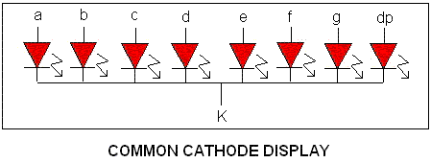
- Common Anode Display: In this type of display all the anode terminals of LEDs are tied together and the cathode terminals decide the status of the LED either ON or OFF.
- To turn ON the LED i.e. segment value of driven segment should be 0 and 1 for turn OFF.

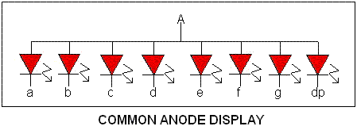

PROCEDURE:

- Launch Impact and Select “Output Cable Setup” menu item.
- Select “Open Cable Plug-in” and type in “digilent_plugin”.
- Right Click in the “Boundary Scan” window to “Initialize Chain”.
- When the device is detected, give path for keydisplay.bit file.
- Right click on the device and click on Program.
- Check for DONE led which goes high indicating successful configuration
- On successful configuration the seven segment display will show “00”.
- For Key board testing as the key is pressed its corresponding number will display on the seven segments.

library IEEE;
use IEEE.STD_LOGIC_1164.ALL;
use IEEE.STD_LOGIC_ARITH.ALL;
use IEEE.STD_LOGIC_UNSIGNED.ALL;

entity matrix_keypad is
port
(
clock,rst : in std_logic;
row_line : in std_logic_vector(3 downto 0);
col_line : out std_logic_vector(3 downto 0);
d : out std_logic_vector(6 downto 0)
);
end matrix_keypad;

architecture Behavioral of matrix_keypad is
signal temp : std_logic_vector(2 downto 0):="000";
begin
test: process(clock,rst) is
begin
if(rst='1') then
d <= "1111111";
elsif rising_edge(clock) then
temp <= temp + 1;

case temp is
when "000" =>
col_line <= "0111"; --first col_line
when "001" =>
if row_line = "0111" then
d <= "0111000"; --K15 : F
elsif row_line = "1011" then
d <= "1100000"; -- K11 : b
elsif row_line = "1101" then
d <= "0001111"; -- K7
elsif row_line = "1110" then
d <= "0000110"; -- K3
end if;
when "010" =>
col_line <= "1011"; --second col_line
when "011" =>
if row_line = "0111" then
d <= "0010000"; -- K14: e
elsif row_line = "1011" then
d <= "0001000"; -- K10 A
elsif row_line = "1101" then
d <= "0100000"; -- K6
elsif row_line = "1110" then
d <= "0010010"; -- K2
end if;
when "100" =>
col_line <= "1101"; --third col_line
when "101" =>
if row_line = "0111" then
d <= "1000010"; -- K13 : d
elsif row_line = "1011" then
d <= "0000100"; -- K9
elsif row_line = "1101" then
d <= "0100100"; -- K5
elsif row_line = "1110" then
d <= "1001111"; -- K1
end if;
when "110" =>
col_line <= "1110"; --fourth col_line
when "111" =>
if row_line = "0111" then
d <= "1110010"; -- K12 : c
elsif row_line = "1011" then
d <= "0000000"; -- K8
elsif row_line = "1101" then
d <= "1001100"; -- K4
elsif row_line = "1110" then
d <= "0000001"; -- K0
end if;

when others => d <= "1111111";
end case;
end if;
end process;
end Behavioral;

Conclusion: -

